Kol Simcha Torah Gazette
For parshas beshalach 5786
Vol 10 Issue 17 (Whole #483) 13 Shevat 5786/ January 31, 2025
Printed L’illuy nishmas Nechama bas R’ Noach, a”h
For a free subscription, please forward your request to keren18@juno.com
Past emails can be found on the website ShabbosStories.com under Brooklyn Torah Gazette
Drasha at Davos: Argentina’s President Javier Milei Shares Devar Torah From Parshas Bo


Argentine President Javier Milei surprised attendees at the World Economic Forum in Davos by weaving a Torah insight into his address, referencing the weekly parshas hashovua, Parshas Bo, to frame his critique of excessive state power and his broader worldview.
Milei had just delivered a forceful speech championing free-market capitalism and describing the United States as a “beacon of light” for the Western world. From there, he pivoted to the Torah portion of the week, using it as a lens through which to view modern global affairs.
“Parashat Bo describes the moment when Moses confronts Pharaoh, a symbol of the oppressive power of the state,” Milei said.
He went on to explain how the sequence of makos that followed Pharaoh’s refusal to release Bnei Yisrael carried enduring meaning. He noted that when Pharaoh “did not free the Hebrew people… the plague of locusts arrived, which signifies famine. Then came the plague of darkness, which signifies the loss of clarity in decision-making. Finally, the plague of the death of the firstborn, which lays bare the fate of a society that denies freedom.”
Milei concluded that the message is directly relevant to the present era, adding, “The analogy to what is happening today in the West is strikingly clear.”
The Argentine leader has consistently voiced strong support for Israel and revealed in 2024 that he has Jewish roots, after his grandfather discovered shortly before his passing that he was Jewish.
During his election campaign, Milei pledged that his first official trip abroad as president would be to Israel, a commitment he fulfilled shortly after taking office.
Last year, Milei was honored with the Genesis Prize, recognizing his outspoken and steadfast backing of Israel at a time when many countries have distanced themselves from the Jewish state.

Reprinted from the January 23, 2026 website of Matzav.com

Different in Speech

Throughout all generations, Yidden have had a language of their own and spoke differently from the nations around them. Generally, this was done by intentionally jumbling the local language, and adding many words from lashon hakodesh. (In fact some speakers of Yiddish call it not “Yiddish,” but “zhargon.”)
Some opinions consider speaking like the nations to be part of the Torah’s explicit prohibition against following chukos hagoyim, the ways of the non-Jews, while the Talmud Yerushalmi includes this practice among the decrees that Chazal instituted during the days of Hillel and Shammai, to keep Yidden separate..
Some tzaddikim have explained that the language of a nation expresses its nature, and speaking that language influences the speaker.

Reprinted from the Parshas Bo 5786 of The Weekly Farbrengen

The Timeless Lesson of
the Splitting of the Sea
From the Teachings of the Lubavitcher Rebbe
Rabbi Menachem Mendel Schneerson, Zt”l
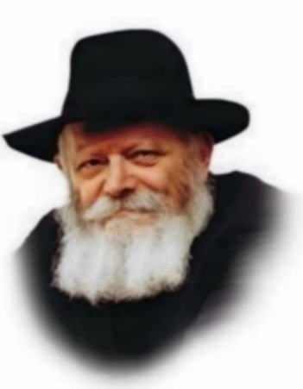
In this week's Torah portion, Beshalach, we read about the splitting of the Sea. This miracle prepared the Jewish people for the giving of the Torah and the Final Redemption.
Concerning the splitting of the sea, the Torah tells us that Nachshon ben Aminadav risked his life to jump into the Sea. It was only after Nachson entered the Sea that the waters parted and the Jews were able to proceed.
How could Nachshon disregard his life and jump into the sea? How could he not!
For Nachshon knew that G-d had taken the Jewish people out of Egypt for the sole purpose of giving them His Torah at Mount Sinai. Nachshon was guided by the desire to advance toward the Torah. It mattered not to Nachshon that a body of water obstructed his path; he jumped into the Sea.
Faced with a seemingly impossible situation the Jewish people had been of several opinions. Nachshon, however, was uninterested in any of their "options" - returning, waging battle or running away - for he knew that none of this would bring them closer to Mount Sinai. He was also not interested in arguments or calculations. There was only one solution: to go forward to Mount Sinai. And so, he did so, with tremendous mesirat nefesh (self-sacrifice).
The portion of Beshalach is generally read on the Shabbat preceeding or following the 10th of Shevat, the anniversary of the passing of the Previous Rebbe, Rabbi Yosef Yitzchak Schneersohn. The circumstances surrounding the splitting of the Sea contain a timeless lesson; so, do the actions of the Previous Rebbe. For throughout his life the Previous Rebbe acted with mesirat nefesh and set an example for all future generations.
The Previous Rebbe did not specifically seek out mesirat nefesh; this was not his intent, as his sole objective was to spread Torah. He did not stop to consider if self-sacrifice was necessary, nor did he pay attention to the prevailing opinions and views of the other Jews of his time. To him, their arguments carried no weight at all. The only thing that motivated the Previous Rebbe was the need to get closer to Mount Sinai. Even if a "sea" stood in his way, he would jump in. What would happen next? That was G-d's concern, not his. This was immaterial to the Previous Rebbe. He simply did what he had to in order to reach Mount Sinai.
From this we learn a lesson to apply in our daily lives. Our function on earth is to serve G-d, to love His creations and bring them closer to Torah. Differences of opinion and approach are not our concern. Our only true goal is to draw nearer to Mount Sinai, and to do so without consideration for any obtacles that seem to obstruct our path.

Reprinted from the Parashat Beshalach 2003/5763 edition of L’Chaim, a publication of the Lubavitch Youth Organization. Adapted from the works of the Lubavitcher Rebbe, Likutei Sichot, Volume 1.

Acting as Moshe

That was Moshe’s unique ability. When the people complained to him, he told them: “... and we, what are we? Your complaints are not against us, but against G-d.” He did not see himself personally as part of the picture at all. He had one goal: to communicate G-d’s message and motivate others to carry it out. In our own lives, each one of us can be a Moshe in a certain sense, for we all have spheres of influence where others look up to us for guidance and direction. If what we give them is ourselves, then our mes-
sage will have a limited scope. But if we can rise above ourselves and communicate G-dly truth, our message will have universal appeal.

Reprinted from the Parshat B0 5786 edition of Living Jewish.

Rav Avigdor Miller on is
There a Cure al pi Torah
For excessive eating?

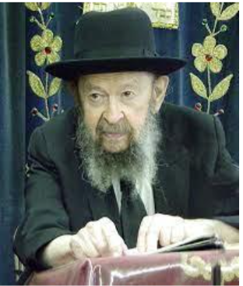

Now I’m not an expert in this subject but I’ll give a little suggestion. First of all, a person should learn the dinim of nedarim. If you’re not able to learn the Gemara, learn it in Shulchan Aruch or learn it at least in Kitzur Shulchan Aruch. Learn how severe a neder is. A neder is very severe.
To make a vow is very severe. First learn that. Then take out of your house all tempting things. No chocolate cake. No candy in your house. See that it doesn’t come into your house. And the people of your family have to cooperate with you.
So, the first thing is, to increase the fear of Hashem by learning the severity of a neder, and the second is to minimize the test by getting the nosherei out of the house.
And then, let’s say, when you finish eating, make a neder that all food is assur to eat until the next meal. Now that’s four hours, let’s say. So, for four hours you can keep a neder. Don’t make a neder for ten days. No. For four hours you can make a neder.
At the end of the four hours, if you want to let go and eat a lot, it’s not so terrible. But after supper, say the same thing again: “I won’t eat anything until tomorrow’s breakfast.” And say it with a neder. However, don’t start this until you first make the hakdamah and learn the chomer, the severity, of nedarim. And it states ̇– Nedarim are a fence for abstinence (Avos 3:13). It helps people.
There was a man who told me he’s going to a place where a certain woman was flirting with him and that day he had to be there. And he was very much disturbed. Very much disturbed. So, I told him, “Swear right now that you won’t talk to her for that day.” And he swore. And the day passed by successfully. That’s the purpose of nedarim and shevuos. Otherwise, don’t do it.
May 1992

Reprinted from the Parshas Bo 5786 email of Torah Avigdor based on a Thursday night lecture by Rav Avigdor Miller, zt”l from May 1992.

Thoughts that Count
for Parsha Beshalach

And Moses took the bones of Joseph with him (Ex. 13:19)
In the Midrash, Moses is described as "wise of heart" for concerning himself with Joseph's bones when the rest of the Jews were helping themselves to the riches that were washed up on the shores of the Red Sea. This is obviously a pious deed, but what does it have to do with wisdom? Moses, as leader of the Jewish people, was like the kohanim (priests) when it came to the prohibition against defiling oneself with the dead. However, by waiting until everyone else was busy, Moses was permitted to do so (indeed, it was a great mitzva), as no one else was free to attend to the task...(Pardes Yosef)

Shabbat Shira
Every year when Parshat Beshalach was read, the Maharal of Prague would instruct the teachers to gather their students (and their parents) in the courtyard of the synagogue to tell them the story of how the birds sang and danced during the splitting of the Red Sea. As related in the Midrash, the Jewish children plucked fruit from the branches of the trees that sprang up on either side and fed them to the birds. After the story was told, kasha (groats) was distributed to the children to scatter about for the birds and chickens in commemoration of this event. The Maharal would then bless the children and their parents that they raise them to a life of Torah and good deeds and lead them to the marriage canopy. (Sefer HaSichot 5702 of the Previous Rebbe)

And you shall hold your peace (Ex. 14:14)
This command was directed against those Jews who wished to engage in prayer instead of actually proceeding into the riverbed. We learn from this that there are times when a Jew must close his prayer book, remove his tefilin, fold his talit and leave the synagogue - in order to save the thousands of Jews who are in danger of drowning in the sea of assimilation, "splitting the sea" and uncovering the light of the Jewish soul that exists within. (The Lubavitcher Rebbe)

Reprinted from the Parashat Beshalach 2003/5763 edition of L’Chaim, a publication of the Lubavitch Youth Organization.

How One Man and His Family Survived the
October 7th Massacre
By Sarah Pachter

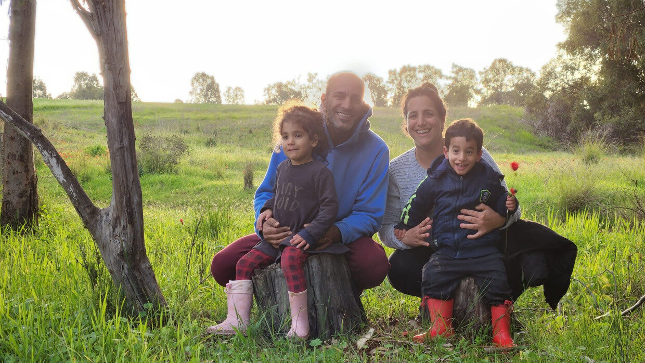
Itay Shabi is certain that he experienced a few miracles that fateful day.
It was 6:30 AM on October 7th when Itay Shabi and his wife, Moran, woke up to the sounds of pervasive rockets and bullets tearing through the sky. Everyone living in Kibbutz Beeri had been jolted from their sleep.
“From the beginning, we sensed that a war had started because it was unusual, even for us. The bullets and rockets did not stop all day long, until we escaped. There was a battlefield of bullets outside. The terrorists were screaming in Arabic outside.”
Pre October 7th, the residents of Kibbutz Beeri lived “harmoniously” next to the border of Gaza. The Jews in the Kibbutz extended tremendous kindness regularly to the Gazan civilians. Many of the members of the Kibbutz would drive to Gaza to transport sick children who needed surgery to Israeli hospitals, wait with them during and after their procedure, and then bring these children back to Gaza.

Running for Shelter
When the rockets began to fly overhead, the first thing Itay and his family did was run to the bomb shelter. Initially, they didn’t close the door because they assumed the rockets would last a few seconds and then they would be able to escape by car if needed. But the rockets continued to fall and they then realized that this was going to be a long ordeal. They closed the door.
“Within a few seconds of closing the door, we started getting text messages that there are terrorists inside of Kibbutz Beeri. People sent pictures to accompany the text messages. We understood what was happening as we started to hear shooting.”
Around 7:00 AM, Itay and his family began to hear screaming in Arabic.
“At 7:10 AM, the terrorists knocked on the door to our house. Just knocking. No banging.” Itay was bewildered. “I was thinking, a simple knock? I do not know why they just knocked. Maybe they were trying to fool us into thinking they were not terrorists.” Thankfully, they did not open the door.
The text messages became more intense. They knew where the terrorists were and could follow their path based on the flow of incoming texts.
After three hours, at 10:30 AM, the terrorists broke into the house.
“We understood that the terrorists were getting closer and closer and closer. I have one boy and one girl who are four years old. We were sitting in the bomb shelter with our twins, Sinai and Benaya.”
The four of them just waited. The army was unable to help because every time soldiers arrived on the scene, they were outnumbered by barbarian terrorists and killed.
“The minute they broke inside the house, the dog started barking. They shot and she started to whimper, so they shot again and again and again. They kept shooting. One of them shouted in Arabic: ‘Khallas Khallas… Which means stop. They did not want to waste more ammunition on the dog. Then it was silent.”
Itay placed his hand tightly onto the door handle of the bomb shelter while silently praying the Shema. This agonizing terror went on for 30 minutes.
They struggled with me. They kept trying to pull the handle down, and with my strength and the help of G-d, I kept pushing the handle up.
“We heard the terrorists breaking everything inside, windows, glass… Then they started to try to open the door. They struggled with me. They kept trying to pull the handle down, and with my strength and the help of G-d, I kept pushing the handle up.”
Moran was sitting on the bed with the two children holding her tightly. Then the electricity went out.
After a few minutes of tugging on the door handle, the terrorists gave up. They took tires, set them aflame, and threw them into the vent of the bomb shelter. “I took out my telephone and used the light to see what was going on. I realized then that smoke was entering the bomb shelter. Almost immediately, the dark smoke began to fill the room.”
Trapped
“I told my wife that we have to surrender. I told her we must put our hands up, and we had no choice but to open the door. I went to open the door but could not get it open. They had broken the handle on the other side in order to trap us.”
When Itay and his family were unable to surrender through the door, there was only one other way out. Through the window.
“I was so scared. I just knew that the moment I opened the window, I was going to get a bullet to my head. I knew it was the end, but we had no choice. We could not breathe anymore. This was the only option.”
Miraculously, the moment Itay opened the window, there was no one in sight. He jumped out first and then Moran handed him the two children.
“She gave me the kids, and I put them down underneath the small palm tree that we have in our garden. I just put them there because it was the closest place next to me. My wife came out, we closed the window, and sat under the palm tree and the branches. We each had a child on our lap.” The tree was slightly bare, but Itay pulled whatever branches were left towards him and they sat there for five, excruciatingly long hours which felt like an eternity.
The terrorists stood 30 centimeters from my body. His leg was right next to me. I have no clue how they passed by several times and didn’t see us.
Within minutes of their escape from their house, Itay’s property was filled with Hamas terrorists and Gazan civilians alike. “We watched the Gazans go inside our home and take everything. These were the same civilians our neighbors had driven to and from the hospital in order to provide surgeries for their children.” They watched this in silence, as they could not move or breathe audibly lest they be discovered.
“The terrorists stood 30 centimeters from my body. His leg was right next to me. I have no clue how they passed by several times and didn’t see us. This is surely a miracle from G-d. Nothing else.”
Itay kept praying, “Give me the strength, G-d, just a little more. Don’t leave me alone, don’t leave me alone.”
At one point, Moran signaled to Itay that they should run towards a bamboo grove since those trees were taller. Itay reasoned, “Listen, there are dozens of terrorists in front of us and for some reason they don’t see us. Something is hiding us, and we can’t move.” He later reflected, “Miracles are hard to grasp—I still do not fully grasp it, and I was the one who experienced it. The terrorists did not just pass once…they passed by us numerous times.”

Moran and Itay hiding
They carried on like this for several more hours. Eventually, the family stopped hearing screaming in Arabic and only heard distant gunfire. They understood from this that the terrorists had moved further away.
The surrounding smoke was building up, and Itay realized that they had to finally leave their hiding spot.
“We held the children, and checked that the area was free and clear. We started to run, and noticed there were terrorists on the roof, shooting at people. Moran took a left turn and then froze out of fear. I started to yell at her to keep moving, and the terrorists must have heard me because they started to shoot at us. We both ran and heard the bullets getting closer and closer. I could hear it in my ears, and I understood we were being chased.”
Itay found some branches on the ground and started to gather them together to make a mound. They dove underneath the pile and hid silently for another five hours, until nightfall.
Up until that point, the family had not eaten a thing, did not have anything to drink, nor had they relieved themselves during the entire ordeal. Their young, 4-year-old twins cooperated every step up the way and did not make a sound or voice any complaint.
“I didn’t tell the children anything. They cooperated because they understood the situation. They saw the fear in our eyes. They went 14 hours without drinking or eating and in complete silence all 14 hours. My kids typically have a lot of energy, especially my daughter. This was another miracle.”

The “Jeep” that G-d Sent
The biggest miracle of all took place when darkness fell and Itay got up to relieve himself.
“I was standing up in front of a tree and looked towards the side. I saw the red lights of a Jeep. I thought it was a Hamas Jeep. All these thoughts were racing through my mind, and I just knew I was going to die. When the Jeep shone its lights on me, I knew we had been caught.
“I started to hear voices, but as they came closer, I heard Hebrew. It was Israeli soldiers. I shouted, ‘Soldier!’”
“Who is this?” they demanded.
“I told him, ‘I am a father with my kids. Please help us!’” They were in safe hands now. Finally.
The soldiers proceeded to drive them back towards their Kibbutz. They saw multitudes of dead bodies of their friends and of terrorists.
Itay and his family also drove by Moran's parents’ home and they tragically saw that it was burnt. When Moran's parents did not pick up the phone they understood the agonizing reality of their death. It was confirmed ten days later.
“The soldiers even took us through where the Nova party took place, and we saw the road filled with bodies. There were hundreds of kids lying all over, burnt. No one can forget what they did to us that day.”
Months later, the soldier that rescued Itay asked him, “In the end, how did you find us? We were on a secret mission, trying to be undetectable.”
Itay responded that it was the red lights from the Jeep.
“What Jeep?” he asked. “We arrived by helicopter and were completely clandestine.”
There was no Jeep. There were no lights. But Itay is still positive that he saw them.
“The power of the army is that they do everything hidden. You can tell me it’s mazal, mazal, mazal, but I’m telling you I saw red lights with my eyes. It was a revelation, more than just mazal. I saw something physical… I am certain it’s a miracle.”

Itay’s First Sukkah Turned Out to be his Ultimate Protection
Perhaps one of the most fascinating parts of the story is that this was the first Sukkot that Itay had ever built a sukkah.
“I wanted to build it with my bare hands. I did not want to buy a premade one. I wanted my children to see me building it, and ask me questions about Sukkot so that I could teach them.”
Itay had gathered planks of wood throughout the Kibbutz and built it himself. He then found a large palm tree in the entrance of the Kibbutz and cut branches for the roof.
There were a lot of gaps in the roof that needed covering. That’s when Itay noticed that he had a dwarfed palm tree in his courtyard. “I had never noticed it before. I cut the branches from it as well in order to fill in the gaps. That tree is the same tree that we hid behind. It was supposed to be more-full, but because I cut branches from it for the sukkah, it was very sparse and bare. We did not have a choice and hid there anyway, but it still saved us.”
Itay is still processing the experience and doesn’t understand why he was spared while others weren’t. He wonders if the merit of making a sukkah enabled him to successfully hide amid the remaining branches of the palm tree.
“Not one souvenir is left of the house. The roof is also burnt, but the sukkah? Nothing happened to it. The flame stopped right at the connection between the house and the sukkah. I had never in my life built a sukkah before. I still do not fully understand it. I came in contact with death, but G-d had another plan for me, maybe some sort of purpose.
“It is impossible for me to say there is no G-d after what I saw. After I was saved ten times from death? It was only G-d. I want the world to understand that we have G-d, but we need to unite. We have two legs, a right leg and a left leg. If we do not all walk together, we will fall. G-d is here and helping us, but for Him to help us, we have to help each other. We have to understand that people can think differently and still get along together.”
A version of this article originally appeared in Ami Magazine.

Reprinted from the current website of aish.com

What You Need to Know About An Upsherenish
By Yehuda Shurpin

There is a widespread custom that a boy’s hair is left uncut for the first three years of his life. When he reaches his third Jewish birthday, family and friends gather for a festive first haircut known as the upshernish (or chalakah). While the rest of his hair is cut short, the child’s peyot (biblically¹ mandated sidelocks) are left intact—this is his initiation into the mitzvah of peyot.²
More than a haircut, the upshernish marks a turning point: from this age, the child begins his formal Jewish education and starts observing basic mitzvot, such as wearing a kippah and tzitzit.³ Rooted in longstanding custom and rich symbolism, the upshernish celebrates a child’s entry into a life shaped by Torah and Jewish values.
While the actual ceremony is straightforward and can be read about in What to Expect at an Upsherin, let’s address some of the questions commonly raised about an upshernish.

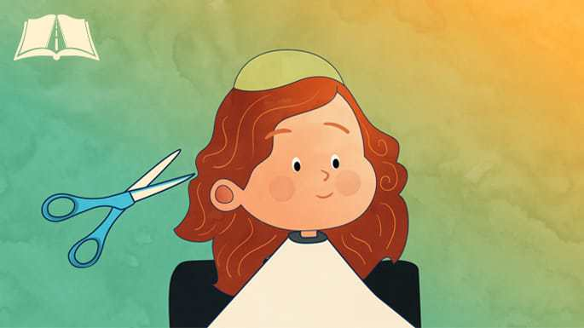
Art by Sefira Lightstone

Who Should Attend, and Where Should it Be Held?
Some have the custom to hold—or at least begin—the upshernish in a holy setting, such as a synagogue or house of study, but it’s perfectly acceptable to hold it at home or another neutral environment.⁴ Relatives and friends are invited to participate, since having a crowd present shows that this is a big deal.

What Does the Child Wear and Do At the Ceremony?
The child should wear tzitzit for the upshernish and continue wearing them regularly from that day on. He recites the verse Torah tzivah lanu Moshe, and other children may complete the set of 12 pesukim traditionally recited on such occasions. The child is also given money to place in a tzedakah box.⁵

Who Cuts the Hair?
You should honor someone special, like a rabbi or mentor, to take the first snip.⁶ On one occasion, the Rebbe advised beginning with a kohen, followed by a levi, and then a yisrael, after which others may participate.⁷ Men and women (provided that it is done in a manner that upholds the standards of modesty),⁸ relatives and non-relatives, can all be honored to take a snip.

Where On the Head to Cut First?
There are different customs about where to start cutting the hair. Some start at the area of the head where tefillin are worn. Others begin near the peyot, close to the ear, emphasizing the mitzvah of not shaving that area (this seems to be the custom of the Rebbe).⁹

Does All the Hair Need to Be Cut During the Ceremony?
No. You can finish it up later or have a (Jewish) barber do it for you, making sure the payot are left intact. The custom is to avoid having a non-Jewish barber finish the haircut.¹⁰

What Exactly Counts as Peyot?
The Torah commands, “Do not round off the edges (peyot) of your heads.”¹¹ The Talmud explains that this refers to the hair between the temples and the ears; “rounding” means removing this area so that the hairline runs smoothly from the forehead to behind the ear. Practically, the peyot span from behind the ear to the forehead and include all the hair in front of the ear.¹²

How Long Should the Peyot Be?
Some authorities prohibit cutting the peyot very close to the skin even with scissors, while others hold that the Torah prohibition applies only to shaving with a razor. The Code of Jewish Law rules according to the latter view but advises stringency by not cutting too close.¹³
In practice, this means leaving the hair long enough that it can be bent over to touch its root—approximately 0.5 cm (about a #2 clipper). This is the minimum requirement; many choose to leave the peyot longer so they are clearly visible.¹⁴
For more on this, see What You Need to Know About Haircuts in Halacha
In many communities, peyot are grown long as a visible expression of Jewish identity, a practice found among Jews from widely different lands. Others, including Chabad, follow the custom of the Arizal,¹⁵ who would trim his peyot with scissors and not let them grow below the ear.¹⁶

Giving Charity
In addition to the general custom of having the child give charity at the upshernish, many have the custom to specifically give the child some money to place in a charity box before they snip the hair.¹⁷

What is Done With the Hair After It’s Cut?
The cut hair should be collected and buried, rather than thrown in the garbage.¹⁸ Some have the custom to weigh the hair and give an equivalent amount of coins to charity.¹⁹

Is There a Festive Meal?
While many mark the upshernish with a celebratory meal, you don’t actually need to serve a full meal; you can just have refreshments such as cake and l’chaim.²⁰ The child is encouraged and given opportunities to recite blessings before eating. There is often singing and music to enhance the joy.²¹

Wash Your Hands
After the child's hair is cut, his hands should be washed (as is proper to be done after any haircut), similar to how the hands are washed in the morning (i.e., three times on each hand, alternating hands).²²

When Should the Upshernish Take Place, and When is It Postponed?
Ideally, it is held on the child’s third Jewish birthday—neither earlier nor later.²³ However, since haircuts are restricted at certain times, the upshernish may be postponed (but should not be done earlier):
Shabbat and festivals: The upshernish is held immediately afterward.
Intermediate days (Chol Hamoed) of Sukkot: If the birthday is on Chol Hamoed (intermediate days of the holidays), then, although ordinarily haircuts are prohibited, an upshernish is permitted to take place.²⁴ Nevertheless, many have the custom to delay until after the holidays.
Intermediate days (Chol Hamoed) of Passover: There are differences of opinion whether the upshernish should be held during the intermediate days of Passover, or whether the restrictions of the Omer have begun and one should wait until Lag BaOmer. Consult your rabbi regarding community custom.
Sefirat HaOmer: If the birthday is before Lag BaOmer, the custom is to have the upshernish on Lag BaOmer. If it’s afterwards, then the upshernish is held shortly before Shavuot.
The Three Weeks of mourning: If the birthday falls between the 17th of Tammuz and Tisha B'Av, the upshernish is delayed until after Tisha B’Av.
Rosh Chodesh: The custom is to refrain from getting haircuts on Rosh Chodesh. As such, while some permit the upshernish, the common practice is to postpone until the following day.
What’s Next for the Child?
A father is obligated to begin teaching his son Torah as soon as the child is able to speak, starting with basic verses such as Torah tzivah lanu Moshe and Shema Yisrael. As the child matures, his learning expands, first at home and then in cheder under a teacher. While no fixed age is mandated, many communities begin formal schooling at age three, on or shortly after the upshernish.
For more on that, see Areinfirinish - A Child's Entry Into Cheder

Footnotes
1. Leviticus 19:27. 2. See Nitei Gavriel, Tiglachat Hayeladim 1:1 and fn. 1-2.
3. See Igrot Kodesh (Rayatz), vol. 8, p. 558; Hayom Yom, 4 Iyar; Shevach Habrit, Minhagei Tisporet Harishonah 3:1-2. 4. Shevach Habrit, Minhagei Tisporet Harishonah 1:7. 5. See Nitei Gavriel, Tiglachat Hayeladim 4:5. 6. Ibid. 7:2.
7. See Yalkut Hatisporet, ch. 6; Nitei Gavriel, Tiglachat Hayeladim 7:4.
8. See Kores Itim, pp. 69-70; Ziv HaMinhagim, p. 105; Yalkut Hatisporet, h, 6; Nitei Gavriel, Tiglachat Hayeladim 7:5. 9. See Nitei Gavriel, Tiglachat Hayeladim 5:1.
10. Ibid. 7:7. 11. Leviticus 19:27. 12. See Talmud, Makot 20b, Kiddushin 35b.
13. Shulchan Aruch, Yoreh De’ah 181:3. 14. See Darkei Teshuvah 181:15.
15. See Shaar Hamitzvot and Taamei Hamitzvot, Parshat Kedoshim.
16. Igrot Kodesh, vol. 20, p. 10. For more on this, see Why Do Some Chassidic Jews Have Long Sidelocks (Peyot)? 17. See Likkutei Levi Yitzchak, Igros, p. 355;
18. See Yalkut Hatisporet, ch. 6; Nitei Gavriel, Tiglachat Hayeladim 14:1.
19.See Teshuvot HaRadbaz 2:606; Nitei Gavriel, Tiglachat Hayeladim 14:2; Shevach Habrit, Minhagei Tisporet Harishonah 1:11.
20. Shevach Habrit, Minhagei Tisporet Harishonah 1:8. 21. Ibid. 1:7.
22. See Shulchan Aruch, Orach Chaim 4:19; Nitei Gavriel, Tiglachat Hayeladim 15:3. 23. Nitei Gavriel, Tiglachat Hayeladim ch. 10; Shevach Habrit, Minhagei Tisporet Harishonah, ch. 2. 24. Shulchan Aruch, Orach Chaim 531:6.

Reprinted from the current website of Chabad.Org

